Chapter 16, Problem 69.

Find I₁(s) and I₂(s) in the circuit of Fig. 16.92.

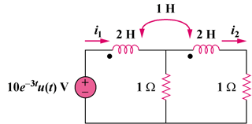

Figure 16.92
For Prob. 16.69.

